

**COLLEGE OF COMPUTER STUDIES**

**CCS007L**

**(COMPUTER PROGRAMMING 2)**

**EXERCISE**

**5**

**POINTERS**

|  |  |  |  |  |
| --- | --- | --- | --- | --- |
| **Student Name / Group Name:** | Patrick Dhale A. Concepcion | |  | |
| **Members (if Group):** |  | **Name** | **Role** |  |
|  |  |
|  |  |
|  |  |
| **Section:** | TX05 | |  | |
| **Professor:** | Jabez Mendoza | |  | |

1. **PROGRAM OUTCOME/S (PO) ADDRESSED BY THE LABORATORY EXERCISE**
   * Design, implement and evaluate computer-based systems or applications to meet desired needs and requirements. [PO: C]

1. **COURSE LEARNING OUTCOME/S (CLO)ADDRESSED BY THE LABORATORY EXERCISE** 
   * Apply the fundamental principles of handling CString values, pointers and memory allocation, and structures using C++in solving computing activities [CLO: 2]

1. **INTENDED LEARNING OUTCOME/S (ILO) OF THE LABORATORY EXERCISE** At the end of this exercise, students must be able to:
   * + Create a program that will traverse pointers on a given array and do some process
     + Create a program that simulates some predefined C-String functions using pointers.

1. **BACKGROUND INFORMATION**

A **pointer** is a variable whose value is the address of another variable. Like any variable or constant, you must declare a pointer before you can work with it. The general form of a pointer variable declaration is:

Type *var-name;

Here, type is the pointer's base type; it must be a valid C++ type and var-name is the name of the pointer variable. The asterisk you used to declare a pointer is the same asterisk that you use for multiplication. However, in this statement the asterisk is being used to designate a variable as a pointer. Following are the valid pointer declaration:

int *ip; // pointer to an integer

double *dp; // pointer to a double float *fp; // pointer to a float char *ch // pointer to character

The actual data type of the value of all pointers, whether integer, float, character, or otherwise, is the same, a long hexadecimal number that represents a memory address. The only difference between pointers of different data types is the data type of the variable or constant that the pointer points to.

Simply, a **pointer** is a variable that **stores the memory address as its value**.

A pointer variable points to a data type of the same type, and is created with the * operator. The address of the variable you're working with is assigned to the pointer:

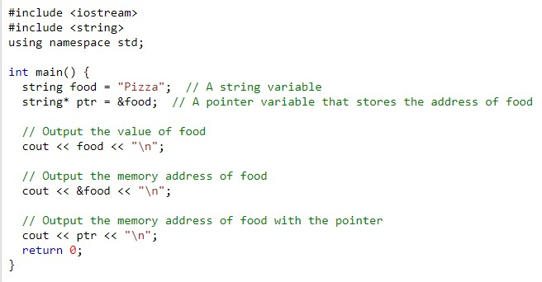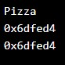

Create a pointer variable with the name ptr, that **points to** a string variable, by using the asterisk sign * (string* ptr). Note that the type of the pointer has to match the type of the variable you're working with. Use the & operator to store the memory address of the variable called food, and assign it to the pointer. Now, ptr holds the value of food's memory address.

1. **GRADING SYSTEM/ RUBRIC**

|  |  |  |  |  |
| --- | --- | --- | --- | --- |
| **Trait** | **(Excellent)** | **(Good)** | **(Fair)** | **(Poor)** |
| **Requirement**  **Specification(30pts)** | Able to identify correctly all input and output and provide alternative.  **(28-20pts)** | Able to identify correctly all input and output **(25-17pts)** | Able to identify only one input or output  **(22-14pts)** | Unable to identify any input and output **(20-11pts)** |
| **Data type(20pts)** | Able to apply required data type or data structure and produce correct results **(1820pts)** | Able to apply required data type or data structure and produce partially correct results **(15-17pts)** | Able to identify required data type or data structure but does apply correctly  **(12-14pts)** | Unable to identify required data type **(9-11pts)** |
| **Input**  **Validation(20pts)** | The program works and meets all specifications. Does exception al checking for errors and out-of- range data **(18-20pts)** | The program works and meets all specifications.  Does some checking for errors and out of range data **(15-17pts)** | The program produces correct results but does not display correctly Does not check for errors and out of range data  **(12-14pts)** | The program produce s incorrect results  **(9-11pts)** |
| **Free from syntax, logic, and runtime errors (10pts)** | Unable to run program **(10pts)** | Able to run program but have logic error **(8-9pts)** | Able to run program correctly without any logic error and display inappropriate output **(6-7pts)** | Able to run program correctly without any logic error and display appropriate output **(5pts)** |
| **Delivery (10pts)** | The program was delivered on time  **(10pts)** | The program was delivered after 5 minutes from the time required. **(89pts)** | The program was delivered after 10 minutes from the time required. **(67pts)** | The program was delivered after 15 (or more) minutes from the time required. **(5pts)** |
| **Use of Comments (10pts)** | Specific purpose is noted for each function, control structure, input requirements, and output results. **(10pts)** | Specific purpose is noted for each function and control structure. **(8-9pts)** | Purpose is noted for each function. **(67pts)** | No comments  included. **(5pts)** |

1. **LABORATORY ACTIVITY INSTRUCTIONS:**

Copy your source codes to be pasted in this document as well as a screen shot of your running output.

**ACTIVITY5.1: strcat function using pointers**

Complete the codes for the stringCat function. It will use the same function which is **strcat** function.

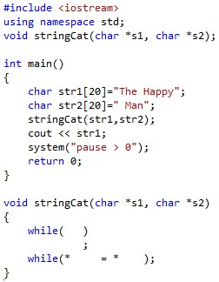

**ACTIVITY 5.2: Reverse string**

Create a program that will return a reverse string using pointer.

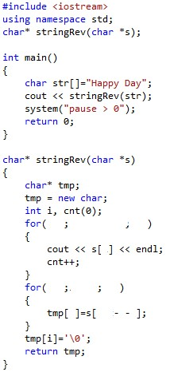

1. **QUESTION AND ANSWER**

Briefly answer the questions below. Avoid erasures. For group activity, specify the name of GROUP MEMBER/s who answered the question. Do not forget to include the source for all NON-ORIGINAL IDEAS.

|  |
| --- |
| • How do you use pointers? |
| • How do you create a dynamic array? |

1. **REFERENCES** 
   * Zak, Dianne (2016). An Introduction to Programming with C++
   * Deitel, Paul & Deitel, Harvey (2012). C++ How To Program, Eighth Edition
   * <https://www.cprogramming.com/tutorial/lesson6.html>